**DAILY ONLINE ACTIVITIES SUMMARY**

|  |  |  |  |  |  |  |  |  |
| --- | --- | --- | --- | --- | --- | --- | --- | --- |
| **Date:** | **01-07-2020** | | | | | **Name:** | **Anix Jugal D’Cunha** | |
| **Sem & Sec** | **8 sem , A sec** | | | | | **USN:** | **4AL16CS013** | |
| **Online Test Summary** | | | | | | | | |
| **Subject** | | **Test was not conducted Today** | | | | | | |
| **Max. Marks** | | **--** | | **Score** | | | **--** | |
| **Certification Course Summary** | | | | | | | | |
| **Course** | **Easy learning C++ for beginners** | | | | | | | |
| **Certificate Provider** | | | **Udemy** | | **Duration** | | | 5 hours |
| **Coding Challenges** | | | | | | | | |
| **Problem Statement:** 1) Java Program to perform Selection Sort on Array. | | | | | | | | |
| **Status: Competed** | | | | | | | | |
| **Uploaded the report in Github** | | | | | **yes** | | | |
| **If yes Repository name** | | | | | **alvas-education-foundation/dcunhaanixjugal** | | | |
| **Uploaded the report in slack** | | | | | **yes** | | | |

Online Test Details: (Attach the snapshot and briefly write the report for the same)

**Test was not conducted Today**

Certification Course Details: (Attach the snapshot and briefly write the report for the same)

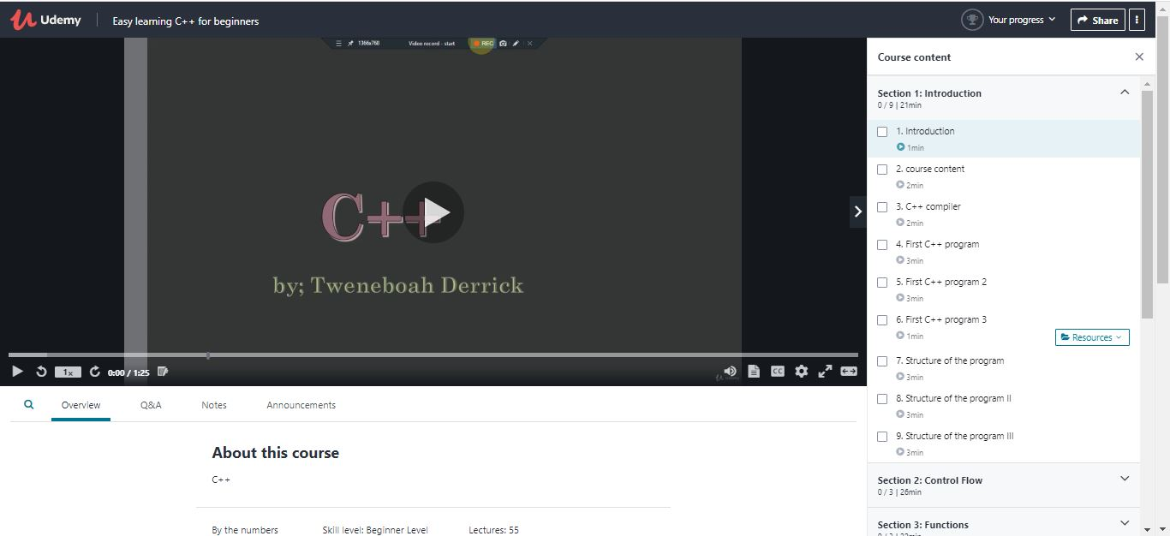

Coding Challenges Details: (Attach the snapshot and briefly write the report for the same)

## Program-> Java Program to perform Selection Sort on Array.

|  |  |
| --- | --- |
|  | |
| class JavaExample |
|  | { |
|  | void selectionSort(int arr[]) |
|  | { |
|  | int len = arr.length; |
|  | for (int i = 0; i < len-1; i++) |
|  | { |
|  | int min = i; |
|  | for (int j = i+1; j < len; j++) |
|  | if (arr[j] < arr[min]) |
|  | min = j; |
|  | int temp = arr[min]; |
|  | arr[min] = arr[i]; |
|  | arr[i] = temp; |
|  | } |
|  | } |
|  | // Displays the array elements |
|  | void printArr(int arr[]) |
|  | { |
|  | for (int i=0; i<arr.length; i++) |
|  | System.out.print(arr[i]+" "); |
|  | System.out.println(); |
|  | } |
|  | public static void main(String args[]) |
|  | { |
|  | JavaExample obj = new JavaExample(); |
|  | int numarr[] = {101,5,18,11,80, 67}; |
|  |  |
|  | System.out.print("Original array: "); |
|  | obj.printArr(numarr); |
|  | obj.selectionSort(numarr); |
|  |  |
|  | System.out.print("Sorted array: "); |
|  | obj.printArr(numarr); |
|  | } |
|  | } |